Transactions

Objectives
At the end of this session, the student will be able to:
- Define and describe transactions
- Implement transactions
- Using implicit, explicit and auto-commit transactions
- Setting isolation levels

Part I- transactions
- Implicit transactions
A new transacton is automatcally started when the earlier
transacton completes and every transacton is explicitly completed by using the ROLLBACK
or COMMIT statement.
Following code snippet defnes a implicit transacton:
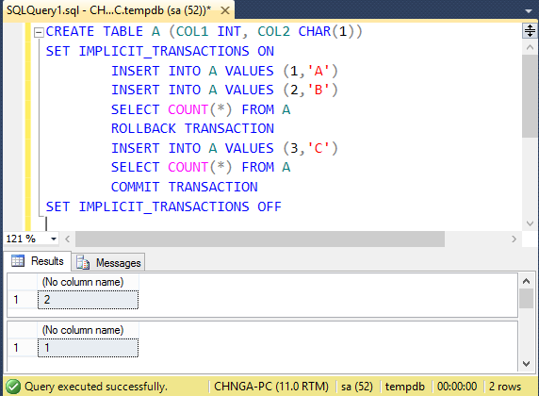

- Explicit transactions
Every transacton explicitly starts with the BEGIN TRANSACTION
statement and ends with a ROLLBACK or COMMIT transacton.

Following code snippet defnes a explicit transaction:
(Using Northwind database)
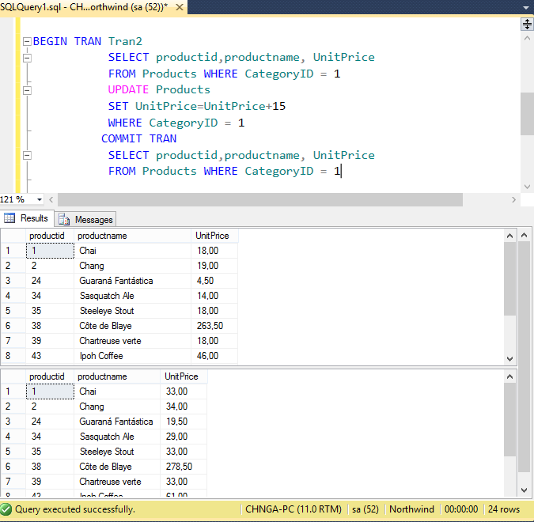

- Using Rollback Transaction

This transaction rolls back or cancels an implicit or explicit transaction to the starting point of
the transaction, or to a savepoint in a transaction.
(Using Northwind database)
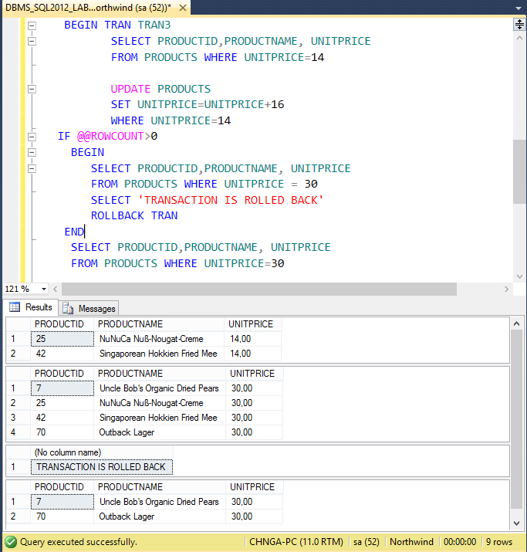

- Isolaton Levels
Create table:
CREATE TABLE dbo.Item (id INT, NAME VARCHAR(50))
INSERT INTO dbo.Item SELECT 1,'a'
INSERT INTO dbo.Item SELECT 2,'b'
INSERT INTO dbo.Item SELECT 3,'c'
SELECT * FROM dbo.Item

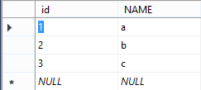
- READ UNCOMMITTED
Specifies that statements can read rows that have been modified by other transactions but not yet committed.
Data of Item table:
Example 1:
Create transaction 1:
SET TRANSACTION ISOLATION LEVEL READ UNCOMMITTED
BEGIN TRAN
UPDATE dbo.Item
SET name = 'x'
WHERE id>2
WAITFOR DELAY '00:00:10' --wait for 10 seconds
ROLLBACK
SELECT * FROM dbo.Item
Create transaction 2:
SET TRANSACTION ISOLATION LEVEL READ UNCOMMITTED
SELECT * FROM dbo.Item

Result of example 1:
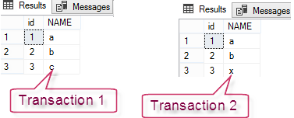
- READ COMMITTED
Specifies that statements cannot read data that has been modified but not committed by other transactions.
Change example 1 to READ COMMITED isolation level
Data of Item table:
Result of the example:
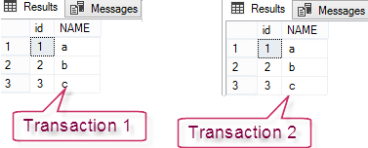
Example 2:
Data of Item table:

Create transaction 1:
SET TRANSACTION ISOLATION LEVEL READ COMMITTED
--SET TRANSACTION ISOLATION LEVEL REPEATABLE READ
BEGIN TRAN
SELECT * FROM dbo.Item
WAITFOR DELAY '00:00:10' --wait for 10 seconds
SELECT * FROM dbo.Item
COMMIT
Create transaction 2:
SET TRANSACTION ISOLATION LEVEL READ COMMITTED
--SET TRANSACTION ISOLATION LEVEL REPEATABLE READ
UPDATE dbo.Item
SET name = 'x'
WHERE id>2
SELECT * FROM item

Result of the example:
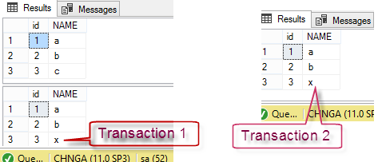

- REPEATABLE READ
Specifies that statements cannot read data that has been modified but not yet committed by other transactions and that no other transactions can modify data that has been read by the current transaction until the current transaction completes.
Change example 2 to REPEATABLE READ isolation level
Data of Item table:

Result of the example:
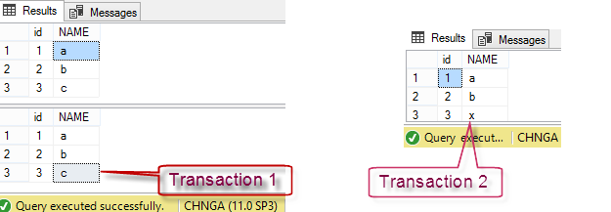

- SERIALIZABLE
Specifies the following:
- Statements cannot read data that has been modified but not yet committed by other transactions.
- No other transactions can modify data that has been read by the current transaction until the current transaction completes.
- Other transactions cannot insert new rows with key values that would fall in the range of keys read by any statements in the current transaction until the current transaction completes.
Example 3:
Data of Item table:

Create transaction 1:
SET TRANSACTION ISOLATION LEVEL SERIALIZABLE
BEGIN TRAN
SELECT * FROM dbo.Item
WAITFOR DELAY '00:00:10' --wait for 10 seconds
SELECT * FROM dbo.Item
COMMIT

Create transaction 2:
INSERT INTO dbo.Item SELECT 4,'d'
SELECT * FROM dbo.Item

Result of the example:
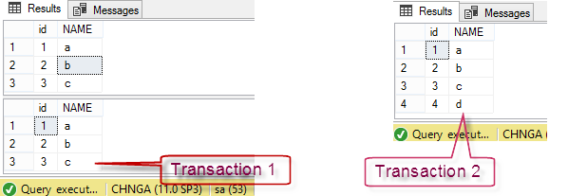

- SNAPSHOT
Specifies that data read by any statement in a transaction will be the transactionally consistent version of the data that existed at the start of the transaction.

ALTER DATABASE tempdb
SET ALLOW_SNAPSHOT_ISOLATION ON

Change example 3 to SNAPSHOT isolation level

